Rating curve

In hydrology, a rating curve is a graph of discharge versus stage for a given point on a stream, usually at gauging stations, where the stream discharge is measured across the stream channel with a flow meter.[1]

If G represents stage for discharge Q, then the relationship between G and Q can possibly be approximated with an equation:

{\displaystyle Q=C_{r}(G-a)^{\beta }}

where {\displaystyle C_{r}} {\displaystyle C_{r}} and {\displaystyle \beta } \beta are rating curve constants, and {\displaystyle a} a is a constant which represents the gauge reading corresponding to zero discharge. The constant {\displaystyle a} a can be measured when a stream is flowing under "section control" as the surveyed gauge height of the lowest point of the section control feature. When a stream is flowing under "channel control" conditions, the parameter {\displaystyle a} a does not have a physical analogue and must be estimated by following standard methods given in literature. The parameter {\displaystyle \beta } \beta is typically in the range of 2.0 to 3.0 when a stream is flowing under section control, and in the range of 1.0 to 2.0 when a stream is flowing under channel control.

For simplicity we assume {\displaystyle \beta } \beta =2.0 when it transitons from section control to cahnnel control. {\displaystyle C_{r}} is dermined by substituting the values from the Tab 1.

Abflusstafel Alle Werte in m3/s

cm 00 10 20 30 40 50 60 70 80 90

-100

0 0,972 2,03 3,23 4,71 6,96 10,5 15,4 21,5 28,8 37,2

100 46,7 57,2 68,8 81,4 95,2 110 126 142 159 177

200 195 213 232 252 273 295 318 343 373 409

300 456 519 601 692 774 842 899 949 999 1050

400 1100 1150 1210 1260 1320 1380 1440 1500 1570 1640

500 1710 1780 1860 1950 2050 2160 2310

Tab 1. Shows realtion between Discharge and height.[2]

The resultant graph looks like

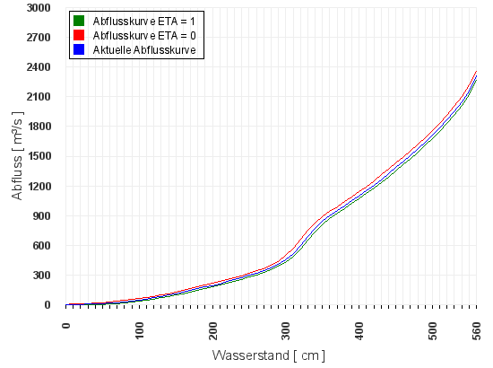

Fig.2 plot of Discharge vs Water height[2]

1. R.W.Herschy (Ed.) (1999). Hydrometry—Principles and Practices. John Wiley & Sons, Chichester. pp. VI+376. [*ISBN*](https://en.wikipedia.org/wiki/International_Standard_Book_Number) [*0-471-97350-5*](https://en.wikipedia.org/wiki/Special:BookSources/0-471-97350-5).
2. http://www.hnd.bayern.de/pegel/isar/plattling-16008506/abflusstafel